Teacher dashboard
1.Condition in the assignment as if I select 2nd or 3rd assignment to assign marks before assigning the marks in 1 it should give warning and it should not add the other assignment marks it should follow sequence and also it is not only for assignments it is for the whole one where we use multiple things as single component
2.edit marks option for every component beside to save marks option

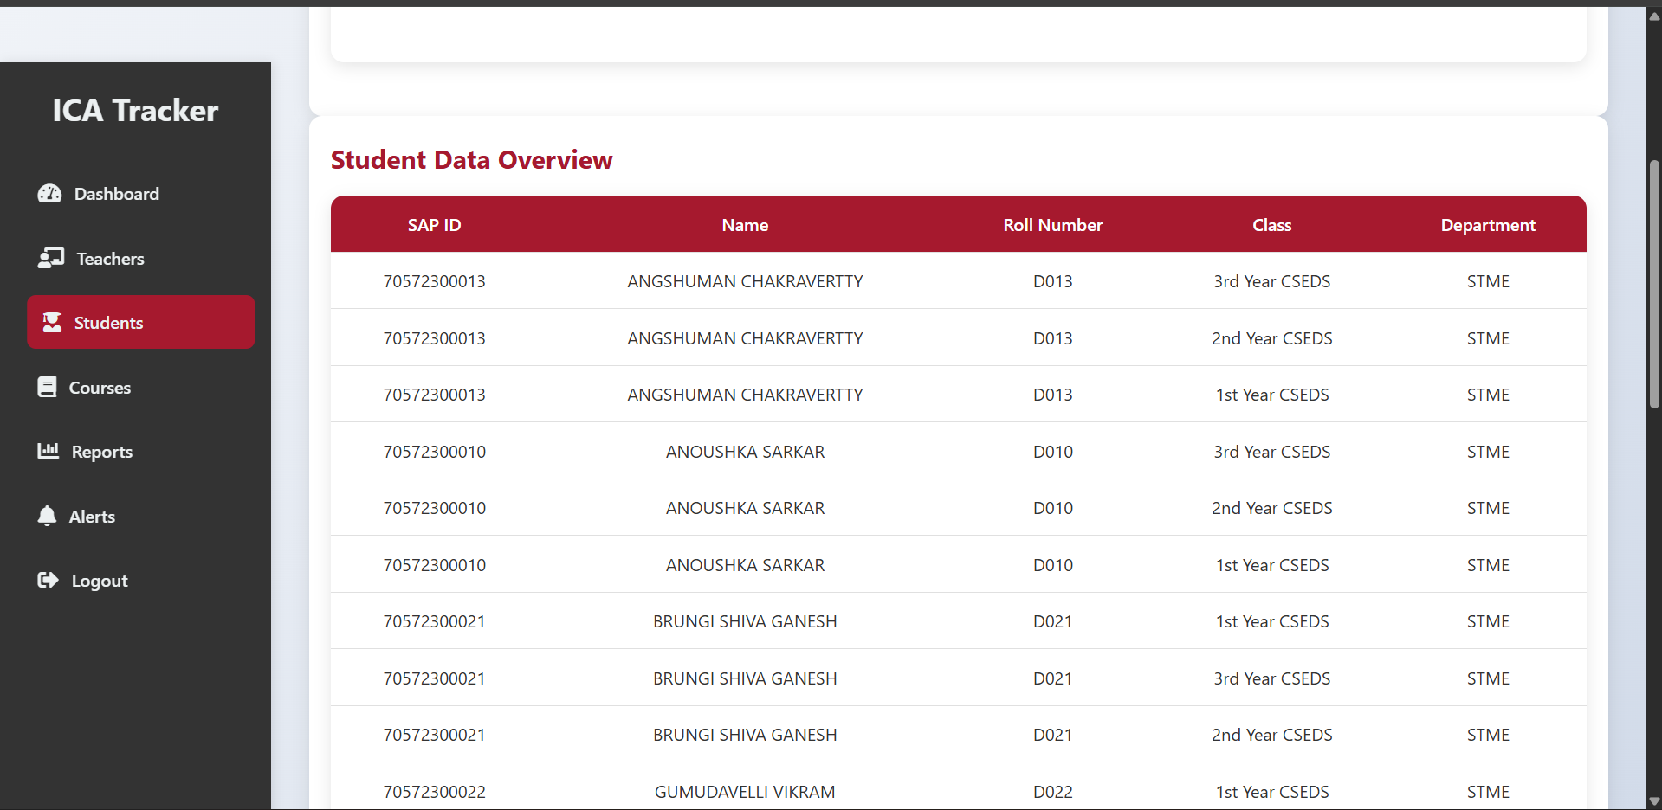
Duplicate entries for students cannot be done while add them in bulk or in the single the \y should their roll no
here it is repetitive for same names
and also keep apply filters here like year section and batch if possible

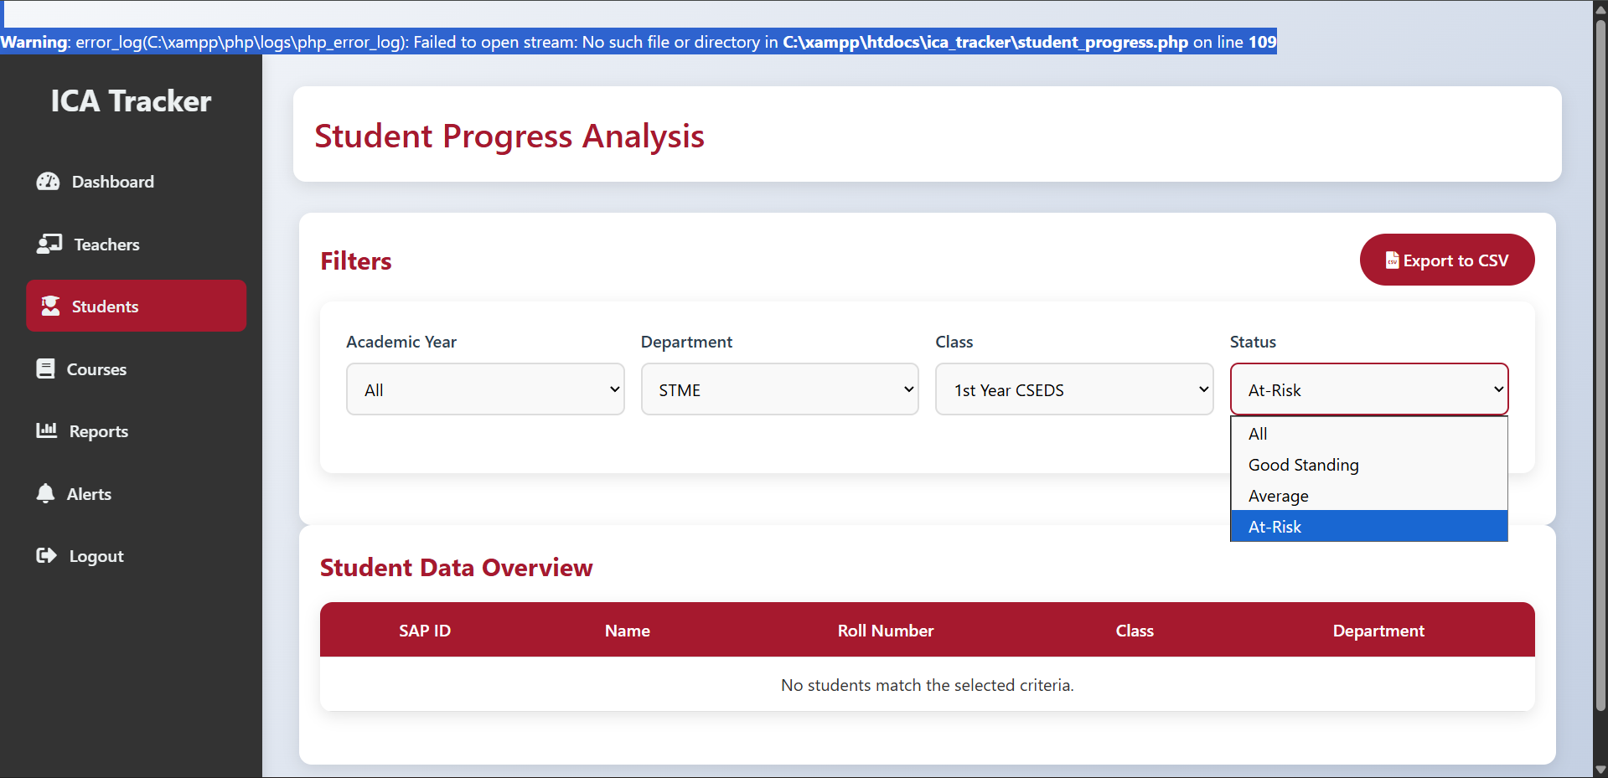
Filters are not working here

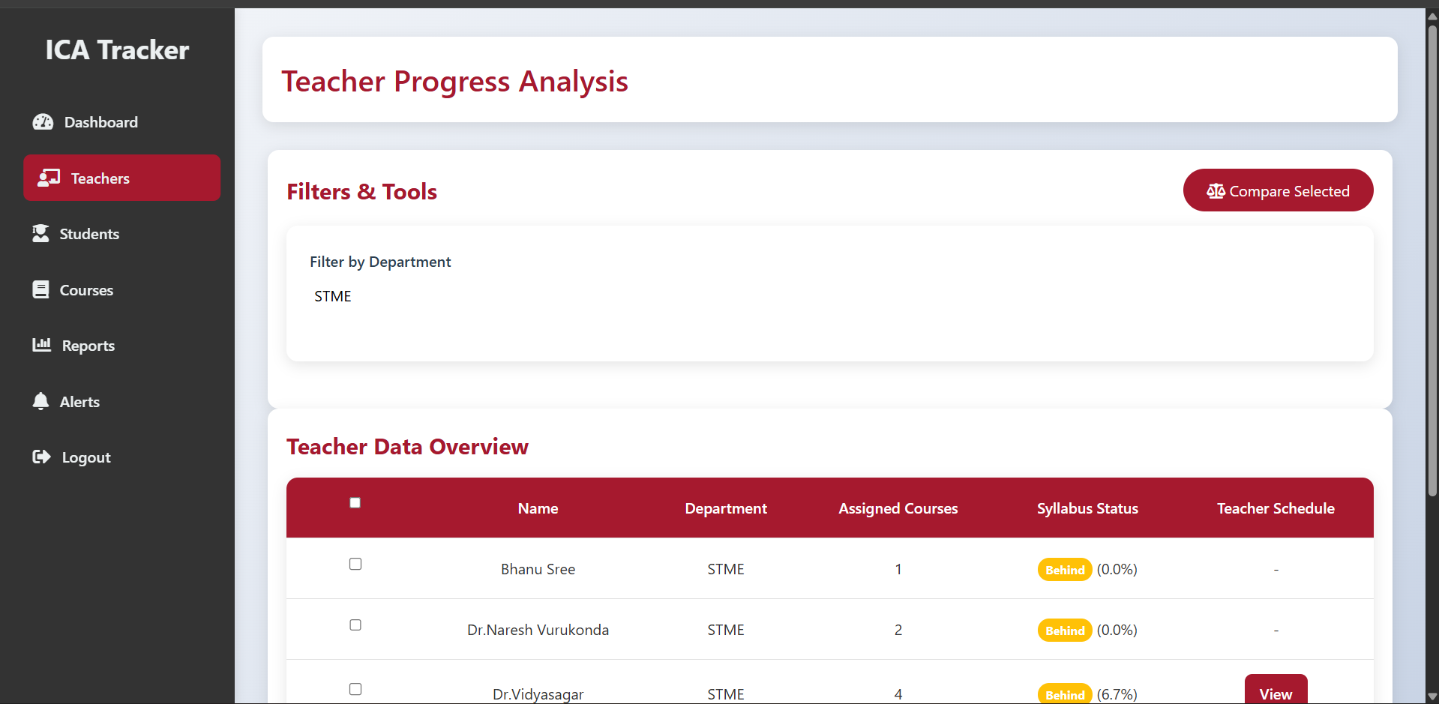here what is the tick mark and also filter by department why

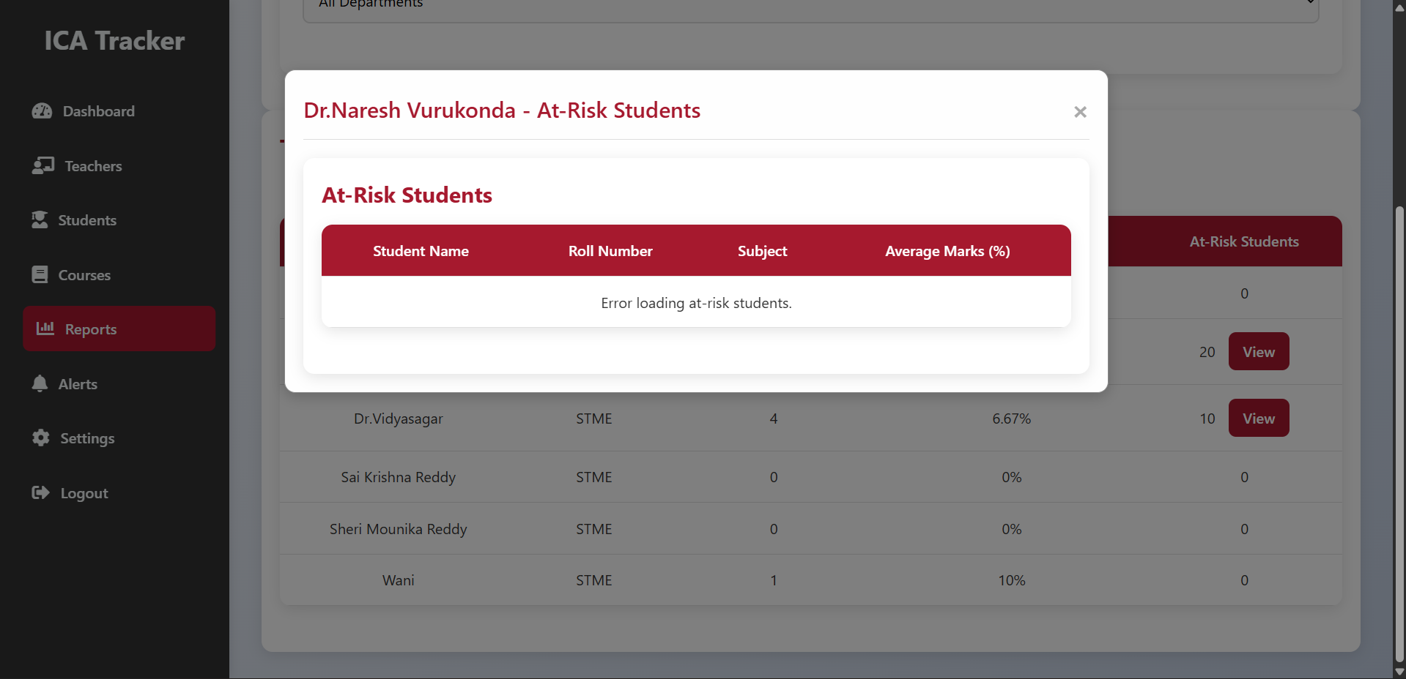not working
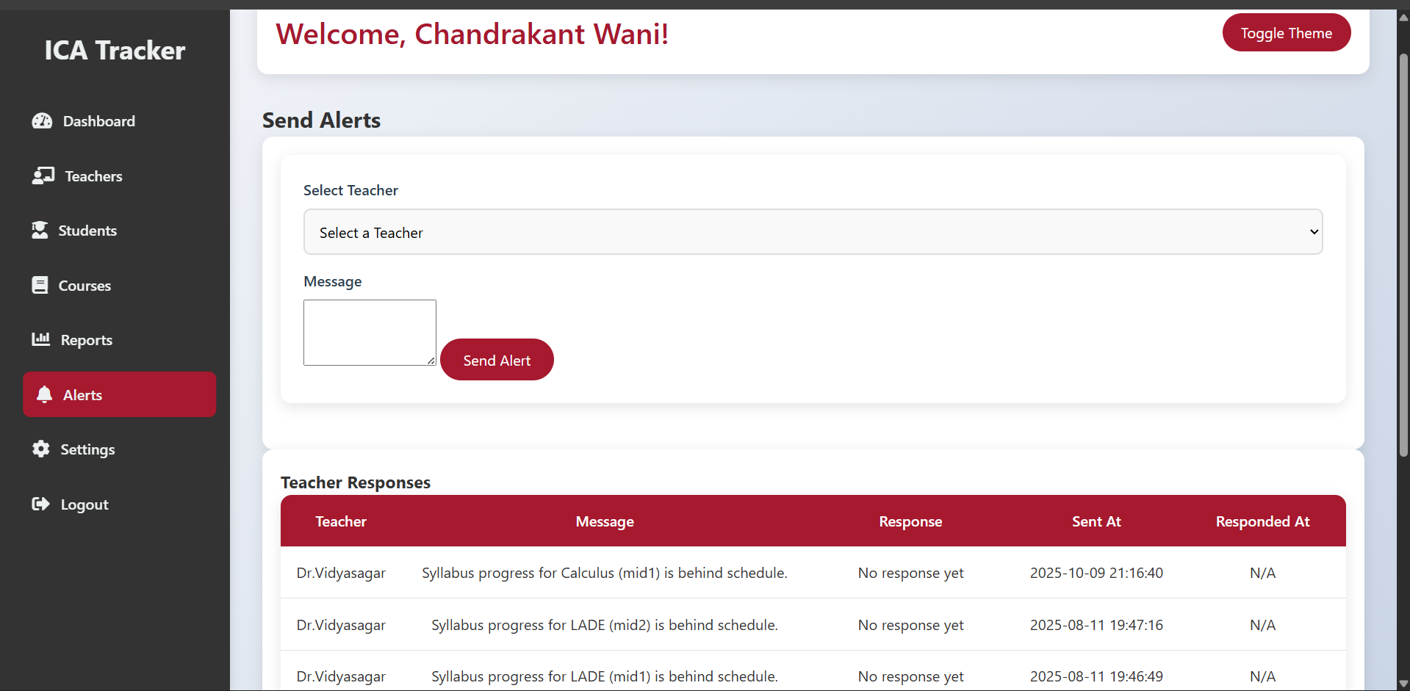big message box
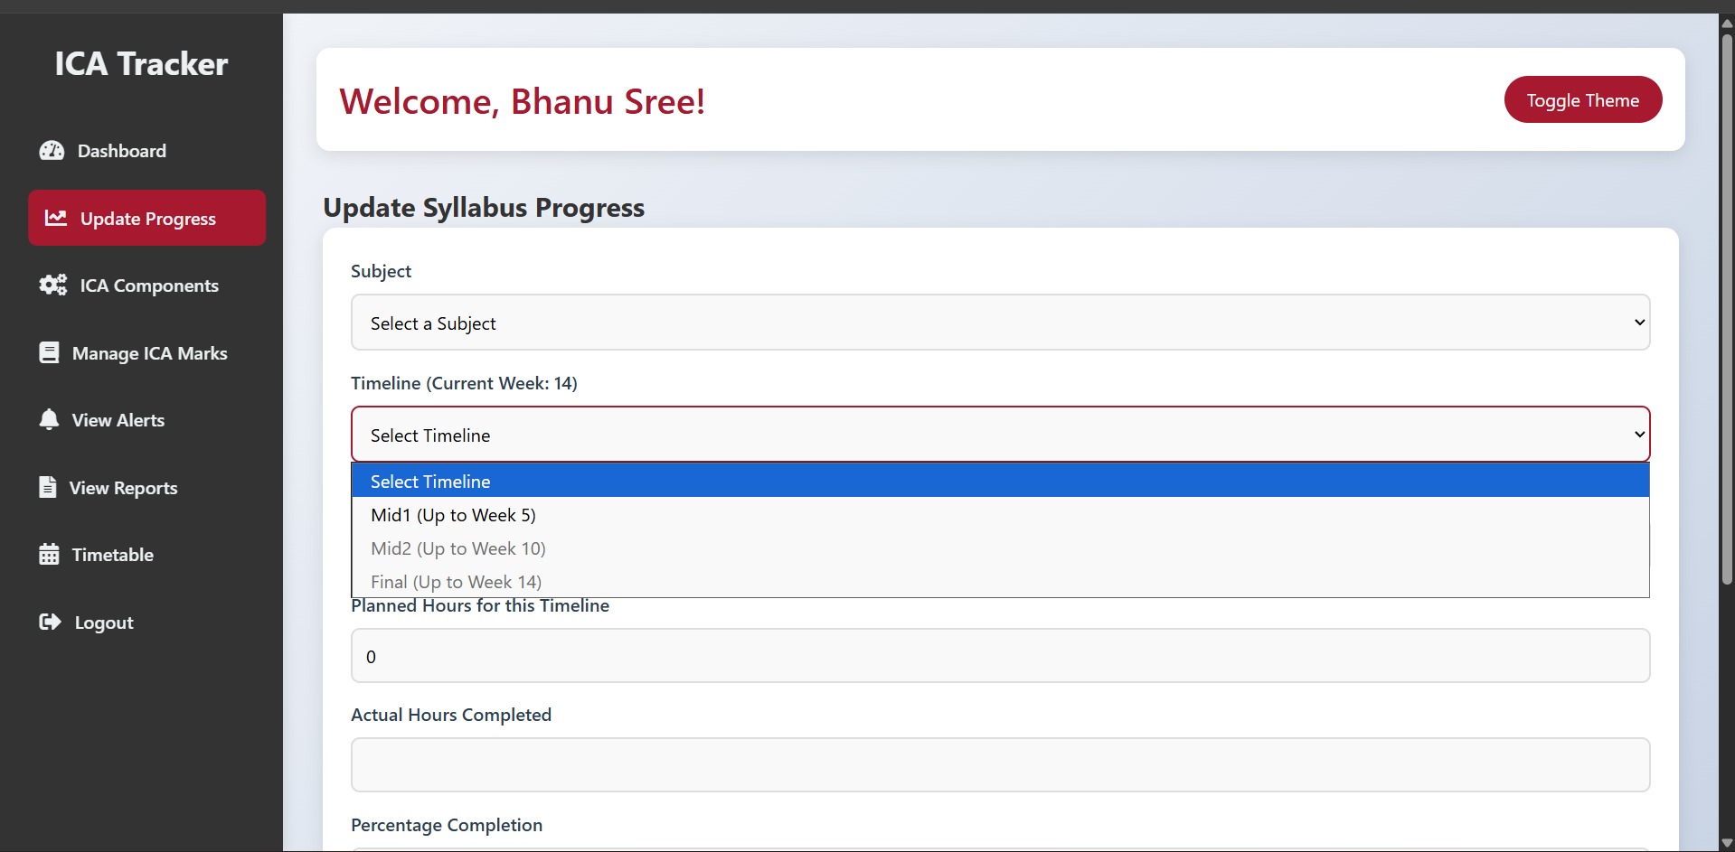
ere also it should work according to the timeline if the teacher not submitted the mid 1 syllabus progress after week 5 then when 6 enters program chair will directly send a alert

